**Windows 10 UWP – Hands on Lab**

**Lab 3:**

**Note**: This demo app created for this lab uses the Visual Studio 2015 RTM and Windows Tools SDK ver 10240.

1. Open the \ViewModels\BBQRecipeViewModel.cs file and add the following lines of code to line 16.

public DelegateCommand SaveCommand { get; private set; }

public DelegateCommand DeleteCommand { get; private set;}

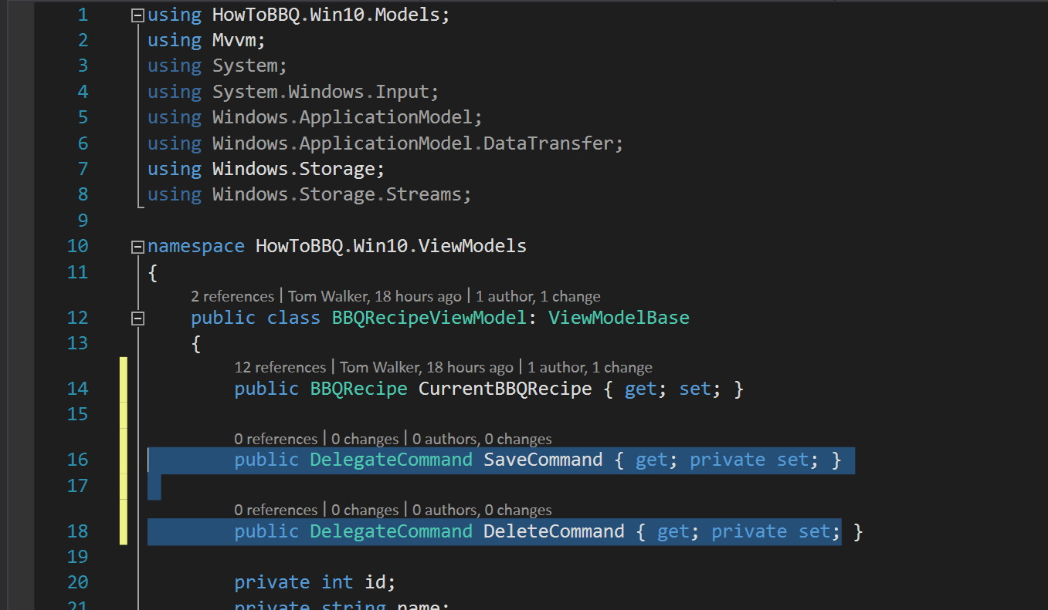

1. Open the \ViewModels\BBQRecipeViewModel.cs file and add the following lines of code to line 54.

SaveCommand = new DelegateCommand(SaveBBQRecipe);

DeleteCommand = new DelegateCommand(DeleteBBQRecipe);

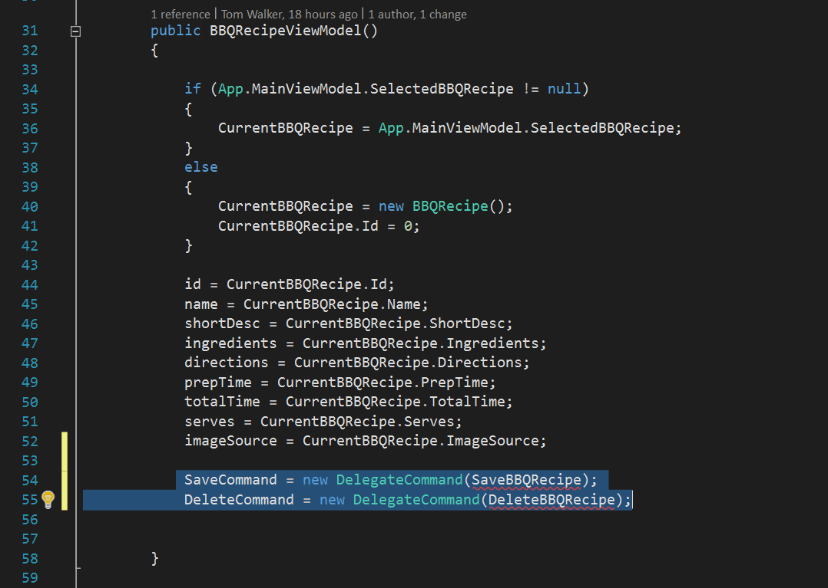

1. Open the \ViewModels\BBQRecipeViewModel.cs file and add the following lines of code to line 168.

public void SaveBBQRecipe()

{

CurrentBBQRecipe.Id = id;

CurrentBBQRecipe.Name = name;

CurrentBBQRecipe.ShortDesc = shortDesc;

CurrentBBQRecipe.Ingredients = ingredients;

CurrentBBQRecipe.Directions = directions;

CurrentBBQRecipe.PrepTime = prepTime;

CurrentBBQRecipe.TotalTime = totalTime;

CurrentBBQRecipe.Serves = serves;

CurrentBBQRecipe.ImageSource = imageSource;

if (id == 0)

{

App.MainViewModel.BBQRepo.Add(CurrentBBQRecipe);

App.MainViewModel.IsDataLoaded = false;

}

else

{

App.MainViewModel.BBQRepo.Update(CurrentBBQRecipe);

}

}

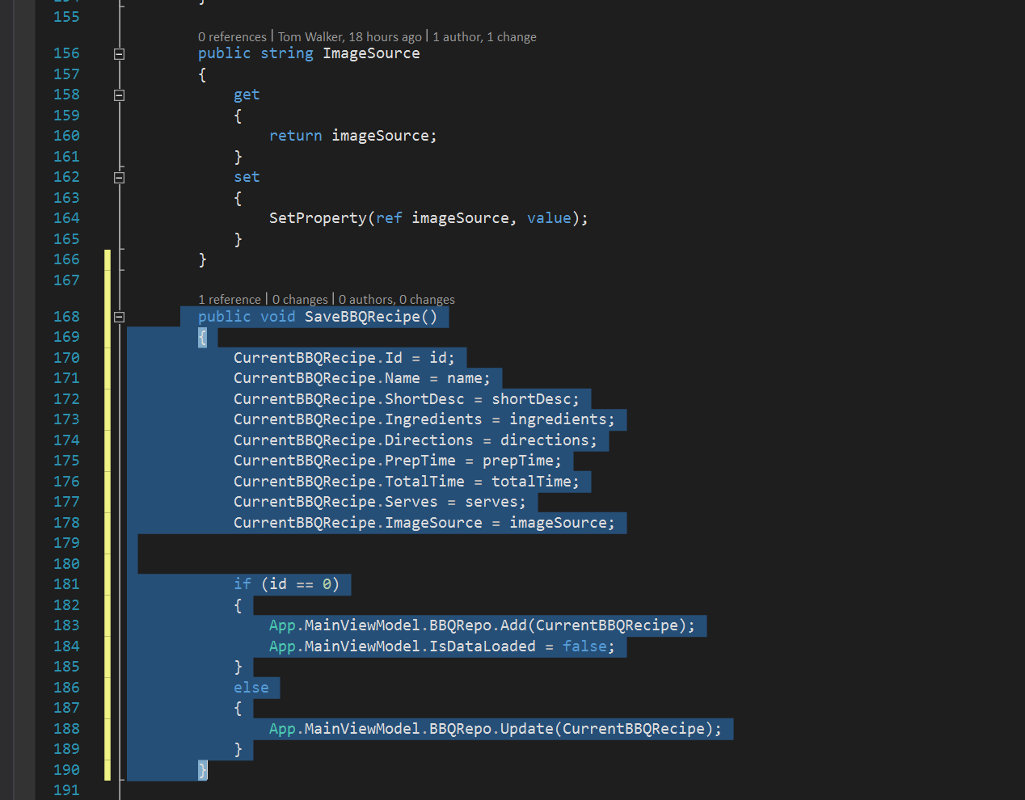

1. Open the \ViewModels\BBQRecipeViewModel.cs file and add the following lines of code to line 192.

public void DeleteBBQRecipe()

{

if (id > 0)

{

App.MainViewModel.BBQRepo.Remove(this.id);

Id = 0;

Name = "";

ShortDesc = "";

Ingredients = "";

Directions = "";

PrepTime = 0;

TotalTime = 0;

Serves = 0;

ImageSource = "";

App.MainViewModel.IsDataLoaded = false;

}

}

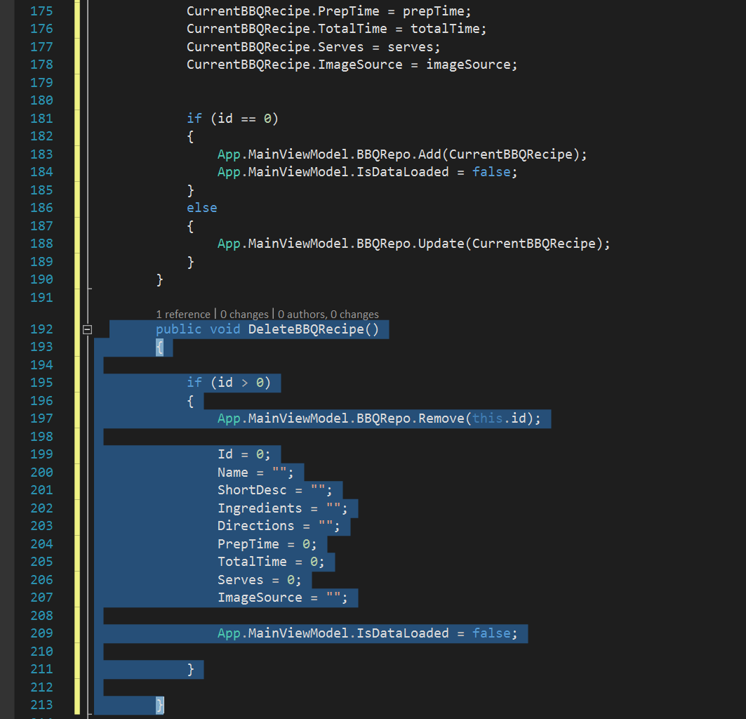

1. Open the \Views\BBQRecipePage.xaml file and add the following lines of xaml code to line 59.

<StackPanel Margin="50,20,0,25" Orientation="Horizontal" Padding="10"

HorizontalAlignment="Center">

<Button Margin="10" x:Name="ButtonSave" Content="Save"

FontSize="32" Command="{Binding SaveCommand}">

<Button.Background>

<LinearGradientBrush EndPoint="0.5,1" StartPoint="0.5,0">

<GradientStop Color="#FF6ACD18" Offset="0.171"/>

<GradientStop Color="#FF0A0A0A"/>

<GradientStop Color="#FF0A0A0A" Offset="0.98"/>

<GradientStop Color="#FF6ACD18" Offset="0.949"/>

</LinearGradientBrush>

</Button.Background>

</Button>

<Button Margin="10" x:Name="ButtonDelete" Content="Delete"

FontSize="32" Command="{Binding DeleteCommand}">

<Button.Background>

<LinearGradientBrush EndPoint="0.5,1" StartPoint="0.5,0">

<GradientStop Color="#FFCD1D18" Offset="0.171"/>

<GradientStop Color="#FF0A0A0A"/>

<GradientStop Color="#FF0A0A0A" Offset="0.98"/>

<GradientStop Color="#FFCD1D18" Offset="0.949"/>

</LinearGradientBrush>

</Button.Background>

</Button>

</StackPanel>

